PRACTICAL 12: Notebook LM Project

Aim

To create revision notes using NotebookLM.

Objectives
•To generate study guide
•To create flashcards

Materials Required
•NotebookLM

Procedure
1. Create NotebookLM project
Start a new project in NotebookLM to organize your materials and AI-generated outputs in one workspace.

2. Upload two resources
Add two documents or sources to the project so the AI can analyze and reference them.

3. Generate study guide
Use NotebookLM’s tools to create a structured study guide summarizing key concepts from the uploaded resources.

4. Generate flashcards
Automatically produce flashcards that highlight important facts, terms, or ideas for easier review.

5. Review accuracy
Carefully check the summaries and flashcards to ensure all information is correct and reflects the original resources.

6. Take screenshots
Capture screenshots of the study guide and flashcards to document your work or include them in your submission.

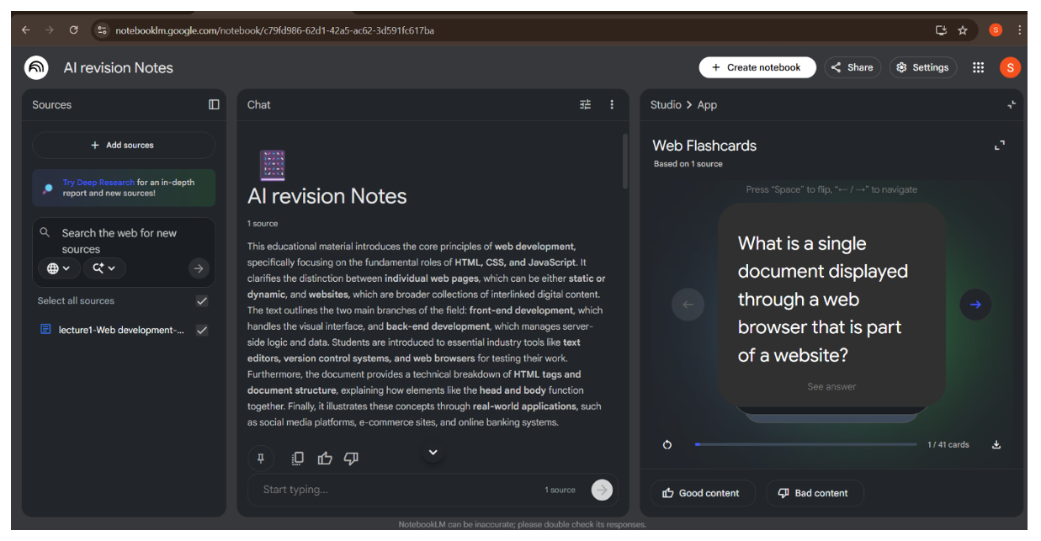
Output:

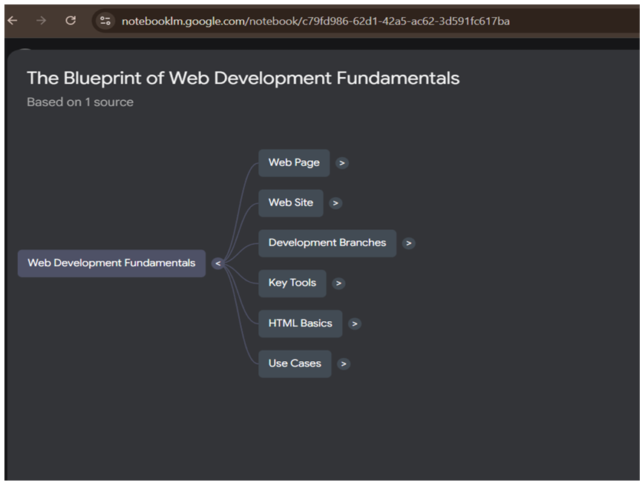
Mind Map:

